**Student Registration Java CRUD Application**

1. Initial state of the application when it's launched.

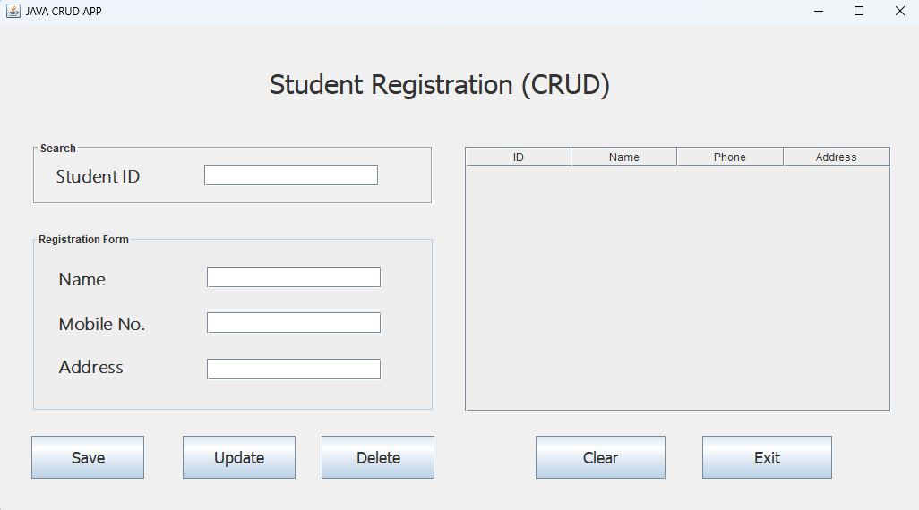

1. State when all fields are empty, and the "Save" button is pressed.

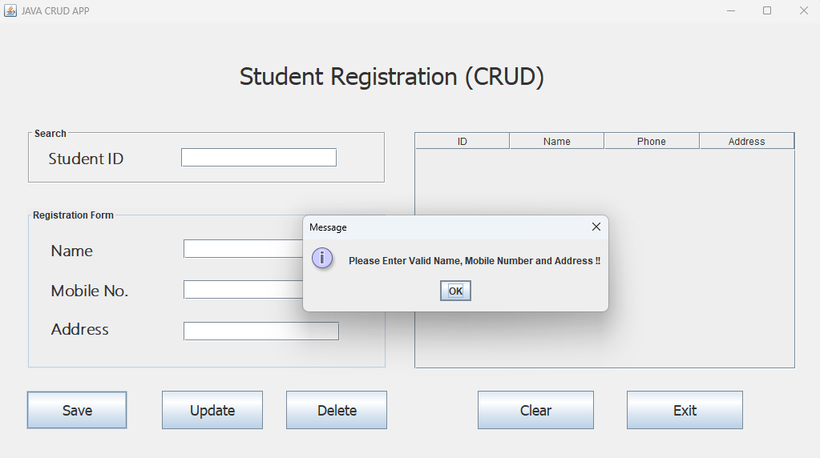

1. State when the name field is filled, but the other fields is empty, and "Save" button is pressed.

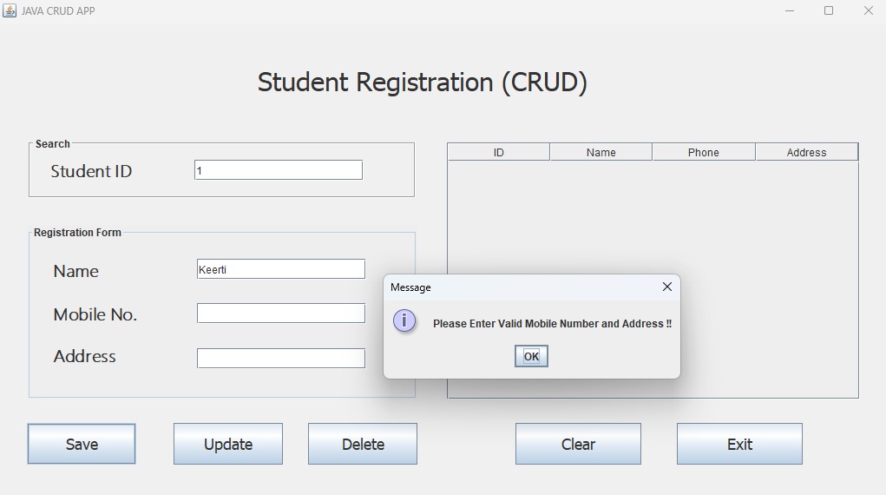

1. State when all fields are filled, and "Save" button is pressed. Then data inserted.

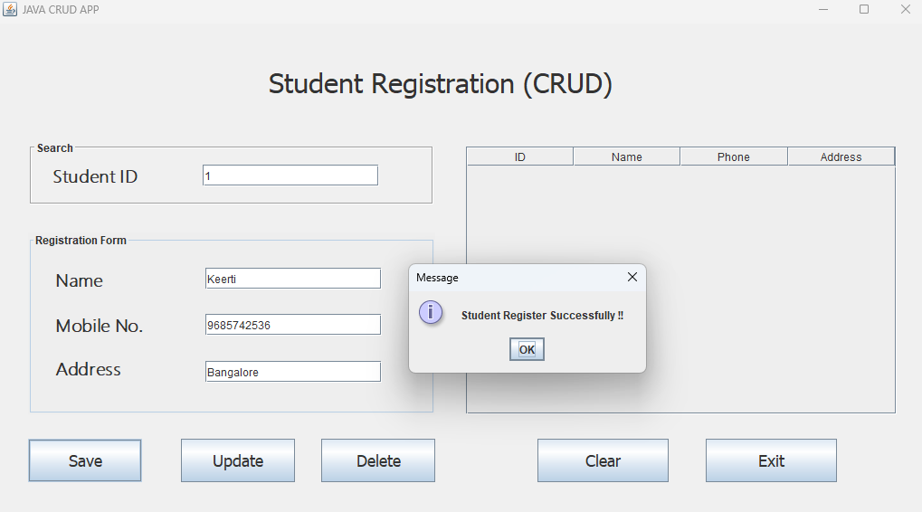

1. State when data inserted, and show data in the table.

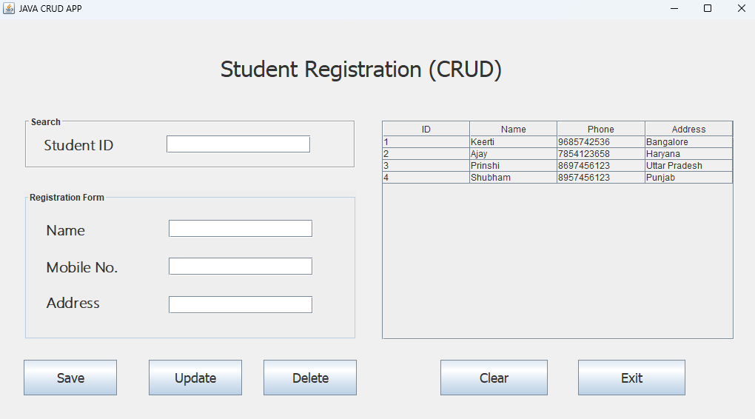

1. State when Searching for a Student by ID.

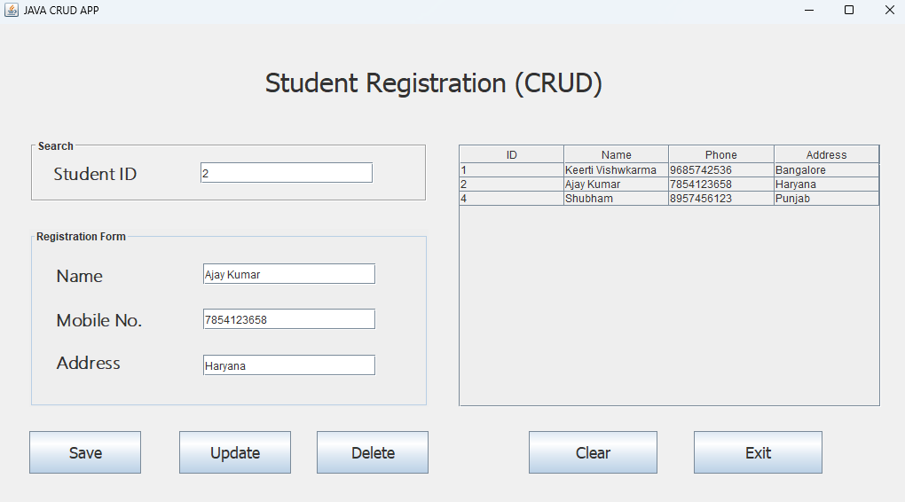

1. State when updating a student using the "Update" button.

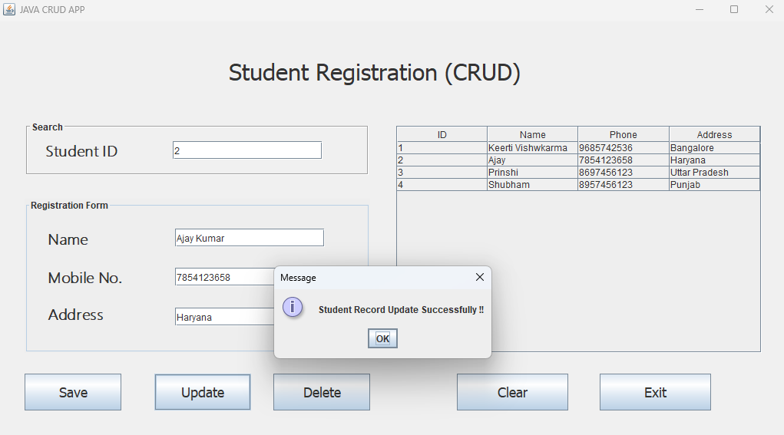

1. State when deleting a student using the "Delete" button.

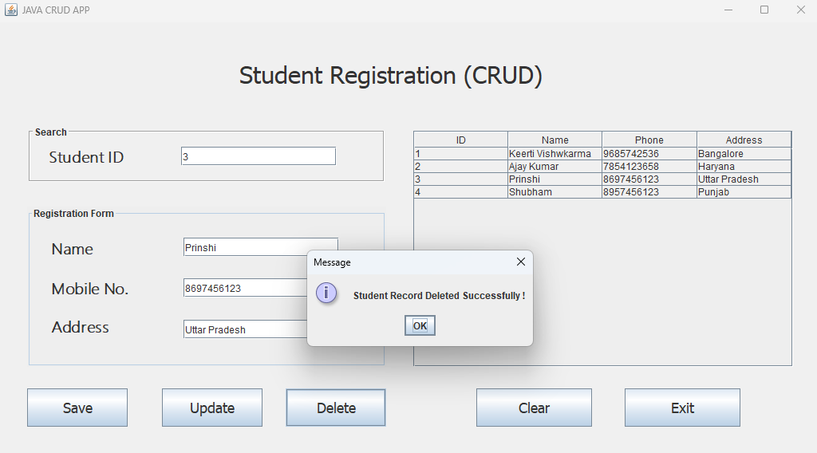

1. Store Data inserted in the database.

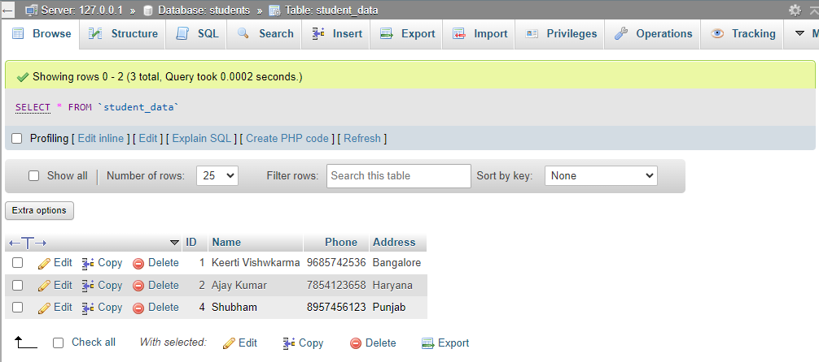

10) State when fields are Reset using the "Clear" button.

